- Packet Encapsulation in Wireshark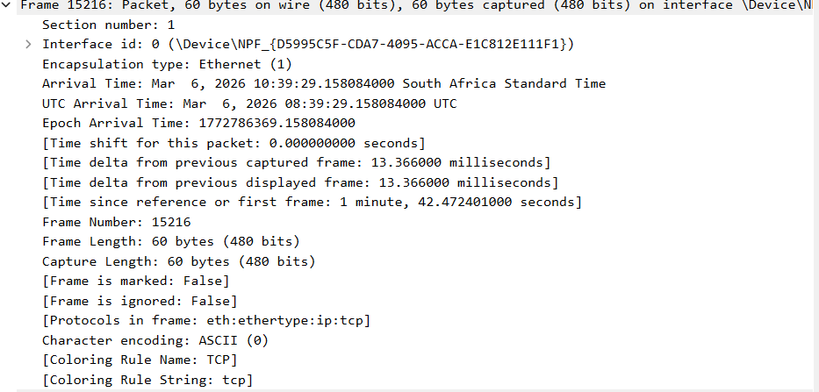
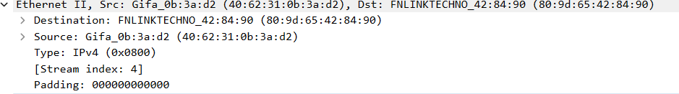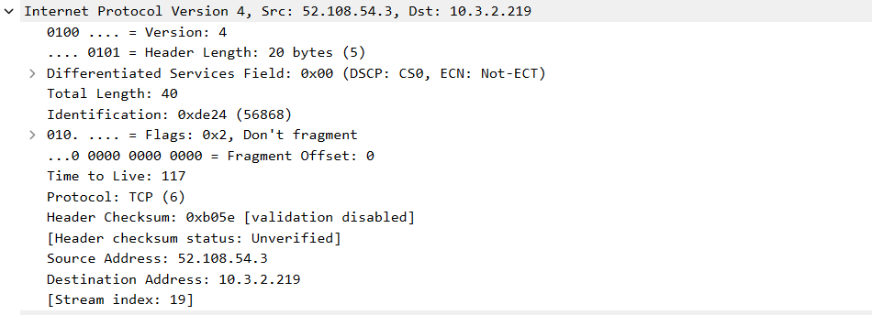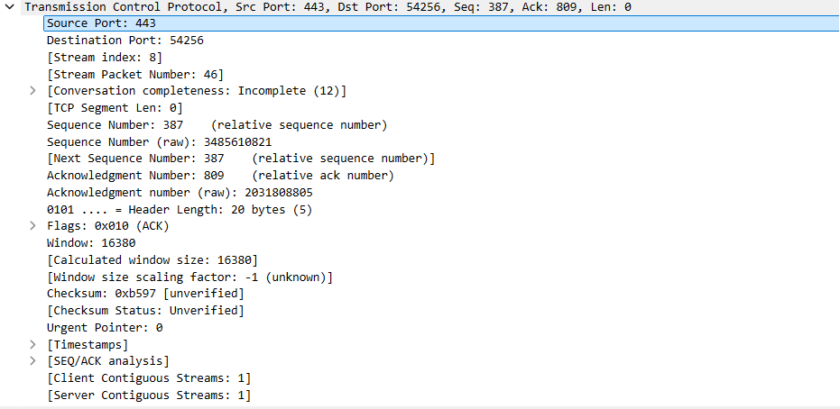
Encapsulation is where data and the methods that operate on that data are bundled together inside a unitb called a class.
It protects data, it has security, in can maintain its code and it is flexible.
- Observe Specific Protocols in Wireshark
TCP Handshake

Packet Tracer

Screenshot 1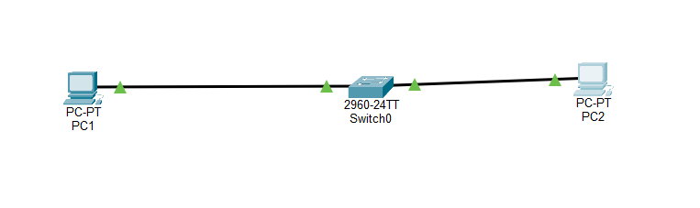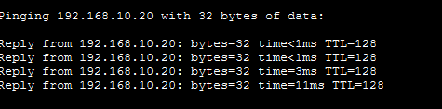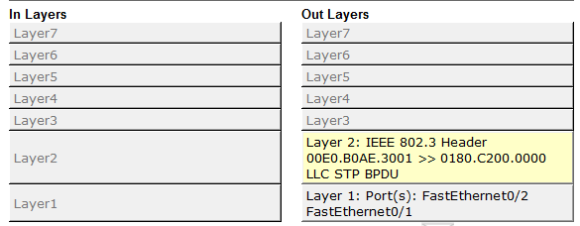
Screenshot 3
Screenshot 2

Written Reflection
- The OSI Model is a conceptual framework developed by ISO to standardise how different computer systems communicate over a network. It is useful because of its layered approach, which simplifies complex networking processes.
- The ping used the prompt protocol, which falls under the Network Layer.
- ARP is a fundamental network protocol used to map an IP address to a MAC address within a local area network. It operates at the Data Link Layer.
- A MAC address is a hardware identifier used at the Data Link Layer of the OSI model to uniquely identify network devices within a network segment and an IP address is a numeric identifier assigned to devices connected to a network that uses the Internet Protocol for communication.
What it does | It has layers with specific roles and responsibilities, ensuring seamless data transmission and troubleshooting.
- 

